Saponins: a possible relation with Fusarium oxysporum f.sp. lilii resistance in lilies (Lilium L.)

Hongzhi Wu^{a,b} Sixiang Zheng^{b*}, Yufen Bi^{c}, Youyong Zhu^{b}
ªThe Gardening Department of Horticulture College, Yunnan Agriculture University Kunming 650201, China;
^{b}The National Center for Agro-biodiversity, Yunnan Agricultural University, Kunming 650201, China;
^{c}Department of Pasture Science, Yunnan Agricultural University, Kunming 650201, China

Abstract
By analyzing saponins content in bulbs of a number of lily genotypes with a known Fusarium resistance, it was found that saponins content in susceptible Oriental lily cultivars is lower than that in the highly resistant lily genotypes like OT hybrids Conca d’or and Robina and the species Lilium dauricum. The results suggest a positive correlation between saponins content in lily bulbs and the resistance to Fusarium oxysporum f.sp. lilii.

INTRODUCTION
Lily (Lilium spp.) is one of the most important ornamental bulb crops worldwide. It is widely cultivated as cut flower, pot and garden plant. However the soil-born fungus Fusarium oxysporum f. sp. lilii, which is causing bulb rot disease, is one of the most serious threats in bulb and cut flower production of lily in China. Breeding for resistance to this disease is therefore an important goal. However, breeding for resistance in lily is limited by the long juvenile phase (2-3 years) and the fact that selection often takes many cycles of breeding in order to introgress desirable agronomic traits from different parents into a single cultivar. Therefore the development of some quick and efficient method can speed up the breeding process considerably.
The correlation of antifungal effects and the accumulation of total saponins from in tissue cultures plants has been shown in several studies (Soetan et al., 2006; Rosca-Casian et al., 2007; Rodriguez et al., 2007). Saponin content could be an indicator for the degree of Fusarium resistance in Lilium (Curir et al., 2003).
In this study, the total saponin content of lily genotypes was measured and compared with the known Fusarium-resistance, in order to find a correlation between these two characters.

MATERIALS AND METHODS

Plant material
Lily genotypes were grown in tissue culture. Cai-74 is a variant of an Oriental selection which showed a significant resistance to Fusarium (Wu, 2008) compared to other genotypes. The highly resistant wild species ‘L dauricum’ and the susceptible Oriental Lilium cultivars ‘Sorbonne’, ‘Siberia’, ‘Tiber’ and the resistant OT cultivars ‘Concad’orr’, ‘Robina’ were as references.

Extraction of total saponins content
For eliminating the influence of growing factors saponin contents was measured of bulbs cultured in vitro of the two outer layers of the scales were used for the test of saponins content. The diosgenin was used as a standard compound to determine the saponins content (from Sigma, pure content ≥99%).
The extraction of total saponins was carried out according to Ren et al. (2005) with minor modification. The bulb scales were dried to approximately 6% water in the drying oven at a temperature of 50°C, and grounded with an electric grinder. The powder was passed through a 0.8 mm mesh sieve. The small powder was defatted in petroleum ether (60-90°C ) by ultrasonic wave processing for 1h, then the samples were extracted with methanol for 1h. The combined methanol extracting solution was dried by 60°C hot water, extracted 4 times by water saturated n-Butanol, and evaporated under reducing pressure. The extracts was dissolved in methanol for measuring the saponin content. The content of total saponins was determined with UV-756 spectrophotometer at 408 nm.

RESULTS AND DISCUSSION

Saponin determination
Calibration curve for diosgenin
Diosgenin (7.2×10⁻² mg/ml) prepared in methanol was used as standard for the saponins content. A calibration curve was prepared for quantitative determination of lily saponins. The amount of Diosgenin and its absorption measured with a spectrophotometer was used to determine the calibration curve. The absorption data for diosgenin and the calibration curve was shown in Fig. 2.

Saponins content in lily bulbs
The bulb scale of tissue culture plants was used for the analysis of total saponins content. The wild species ‘L dauricum’ is a highly resistant source to Fusarium oxysporum f.sp. lilii (Lim et al, 2003; Straathof et al, 1994). As presented in Table 1, the saponin content determined by spectrophotometry showed that the highly resistant wild L. dauricum had the highest level - 4.59mg/g, followed by the resistant Cai-74 with 4.01mg/g. The resistant OT cultivars ‘Conca d’or’ and ‘Robina’ had a higher saponins content - 3.70 mg/g and 2.83 mg/g, than the susceptible Oriental lily cultivars ‘Sorbonne’, ‘Siberia’ and ‘Tiber’ (Table 1). These results suggest that total saponins content in lily bulbs could possibly used as indicator for Fusarium oxysporum resistance in lilies.
In this study we showed that total saponins in lily bulb are positively correlated with resistance to Fusarium oxysporum f.sp. lilii. When these findings are proved on a larger scale this could be a method to speed up the breeding for resistance to this disease.

ACKNOWLEDGEMENTS
The author would like to thank professor Long Chunlin and Wang Yuehu of Kunming Institute of Botany, China Academy Science for valuable advice and equipment support to determine saponins content, and professor Lei Jiajun of Shanyang Agricultural University for kindly giving L. dauricum.

Literature Cited
Curir, P., Dolci M., Pasini C. ,Capponi A., Galeotti F., Grassotti A. 2003. Saponin content in lily (Lilium Hybr.) as an indicator of the resistance degree against Fusarium oxysporum f.sp. lilii. Italus Hortus. Societa Orticola Italiana, Florence, Italy: 10(4), Supplemento, 291-293.
Lim, J.H., Rhee, H.K., Kim, Y.J., Lim, K.B., Van Tuyl, J.M. 2003. Resistance to Fusarium oxysporum f.sp. lilii in Lilium. Acta Hort. 620:311-318.
Rodriguez, D.J., Hernandez-Castillo, D., Angulo-Sanchez, J.L., Rodriguez-Garcia, R.J., Quintanilla, A.V., Lira-Saldivar, R.H. 2007. Antifungal activity in vitro of Flourensia spp. extracts on Alternaria sp., Rhizoctonia solani, and Fusarium oxysporum. Industrial Crops and Products, 25:111–116.
Rosca-Casian, O., Parvu, M., Vlase, L., Tamas, M. 2007. Antifungal activity of Aloe vera leaves. Fitoterapia. 78(3):219–222.
Soetan, K.O., Oyekunle, M.A., Aiyelaagbe, O.O., Fafunso, M.A. 2006. Evaluation of the antimicrobial activity of saponins extract of Sorghum bicolor L. Moench. African Journal of Biotechnology. 5 (23): 2405-2407.
Straathof, Th.P., Van Tuyl, J.M. 1994. Genetic variation in resistance to Fusarium oxysporum f.sp. lilii in the genus Lilium. Ann. appl. Biot., 125: 61-72.
Ren, F.L., Qiu, C.G., Lian, Y. 2005. Extraction process of total saponins from Lilium brownii. J. Cent. South Uni. (Science and technology). 36 (1): 69-72.
Wu, H. 2008. Lilium oriental breeding via 2n gametes and an analysis on resistance of their progenies to Fusarium bulb rot disease. PhD-thesis Yunnan Agricultural University, China, 99 pp.

Tables

Table 1 Quantitative determination of lily saponin contents
Genotype | Field reaction to Fusarium | Abs (408 nm) |  |  | Saponins content of solution/（µg·ml-1） | Saponins content of bulb scale /（mg·g-1）
Genotype | Field reaction to Fusarium | A1 | A2 | A3 | Saponins content of solution/（µg·ml-1） | Saponins content of bulb scale /（mg·g-1）
Cai-74 | resistant | 0.2201 | 0.2357 | 0.2327 | 7.2130 | 4.01
Siberia | moderate | 0.1189 | 0.1005 | 0.1044 | 3.4599 | 1.92
Conca d’or | resistant | 0.2218 | 0.2185 | 0.1946 | 6.6605 | 3.70
Sorbonne | moderate | 0.1190 | 0.1307 | 0.1249 | 4.0677 | 2.26
Tiber | moderate | 0.0941 | 0.1035 | 0.1141 | 3.3364 | 1.85
Robina | resistant | 0.165 | 0.160 | 0.159 | 5.0988 | 2.83
L. dauricum | Highly resistant | 0.2567 | 0.2571 | 0.2770 | 8.2654 | 4.59

Figures

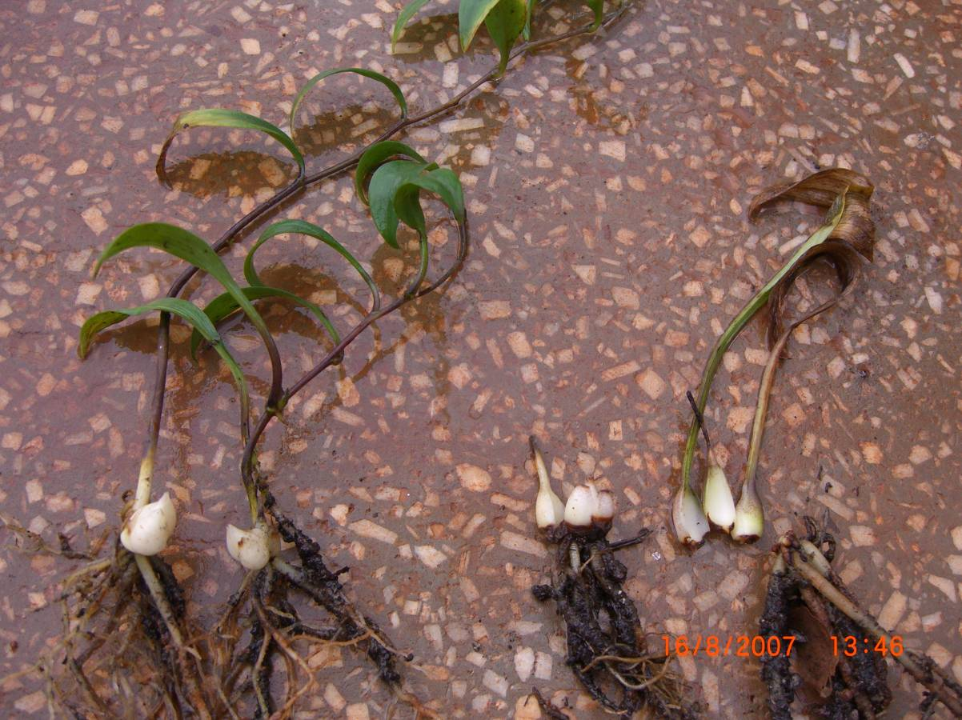
Fig.1 Plants of a resistant variant Cai-74 (left) and susceptible Oriental Lilium cultivar (right) after inoculation with Fusarium oxysporum f.sp. lilii.

Fig. 2. The calibration curve of saponin content and absorbance.

